Using keyboard shortcuts is one of the easiest ways to improve your workflow and become a coding ninja in the process... and it makes sense.

You’re faster with keyboard shortcuts than you are with a mouse. Try them out and unlock your full potential!

**[[](https://classroom.udacity.com/nanodegrees/nd001/parts/aabd87fc-6edf-4818-a911-15dfa9cabcb8/modules/4d4626ff-de39-4af7-9cf1-a26774ee022c/lessons/7118285430/concepts/71211966890923)](https://classroom.udacity.com/nanodegrees/nd001/parts/aabd87fc-6edf-4818-a911-15dfa9cabcb8/modules/4d4626ff-de39-4af7-9cf1-a26774ee022c/lessons/7118285430/concepts/71211966890923)**

Every editor comes with a ton of keyboard shortcuts that help cut down on the amount of time you spend writing code. It would be almost impossible to list all of them here, so for brevity we've highlighted the most useful commands for **Sublime Text** and **Atom**.

**Commands**

This page is filled with keyboard shortcut keys *and* example videos of how they're used. You don't need to *read* the entire page. Instead, use the links below to jump to specific commands.

* [**cut, copy, paste**](https://classroom.udacity.com/nanodegrees/nd001/parts/aabd87fc-6edf-4818-a911-15dfa9cabcb8/modules/4d4626ff-de39-4af7-9cf1-a26774ee022c/lessons/7118285430/concepts/71211966890923#cut-copy-paste)
* [**undo, redo**](https://classroom.udacity.com/nanodegrees/nd001/parts/aabd87fc-6edf-4818-a911-15dfa9cabcb8/modules/4d4626ff-de39-4af7-9cf1-a26774ee022c/lessons/7118285430/concepts/71211966890923#undo-redo)
* [**duplicate**](https://classroom.udacity.com/nanodegrees/nd001/parts/aabd87fc-6edf-4818-a911-15dfa9cabcb8/modules/4d4626ff-de39-4af7-9cf1-a26774ee022c/lessons/7118285430/concepts/71211966890923#duplicate)
* [**select**](https://classroom.udacity.com/nanodegrees/nd001/parts/aabd87fc-6edf-4818-a911-15dfa9cabcb8/modules/4d4626ff-de39-4af7-9cf1-a26774ee022c/lessons/7118285430/concepts/71211966890923#select)
* [**move cursor**](https://classroom.udacity.com/nanodegrees/nd001/parts/aabd87fc-6edf-4818-a911-15dfa9cabcb8/modules/4d4626ff-de39-4af7-9cf1-a26774ee022c/lessons/7118285430/concepts/71211966890923#move-cursor)
* [**jump**](https://classroom.udacity.com/nanodegrees/nd001/parts/aabd87fc-6edf-4818-a911-15dfa9cabcb8/modules/4d4626ff-de39-4af7-9cf1-a26774ee022c/lessons/7118285430/concepts/71211966890923#jump)
* [**indent, unindent**](https://classroom.udacity.com/nanodegrees/nd001/parts/aabd87fc-6edf-4818-a911-15dfa9cabcb8/modules/4d4626ff-de39-4af7-9cf1-a26774ee022c/lessons/7118285430/concepts/71211966890923#indent-unindent)
* [**toggle comment**](https://classroom.udacity.com/nanodegrees/nd001/parts/aabd87fc-6edf-4818-a911-15dfa9cabcb8/modules/4d4626ff-de39-4af7-9cf1-a26774ee022c/lessons/7118285430/concepts/71211966890923#toggle-comment)
* [**tab management**](https://classroom.udacity.com/nanodegrees/nd001/parts/aabd87fc-6edf-4818-a911-15dfa9cabcb8/modules/4d4626ff-de39-4af7-9cf1-a26774ee022c/lessons/7118285430/concepts/71211966890923#tab-management)
* [**quick open**](https://classroom.udacity.com/nanodegrees/nd001/parts/aabd87fc-6edf-4818-a911-15dfa9cabcb8/modules/4d4626ff-de39-4af7-9cf1-a26774ee022c/lessons/7118285430/concepts/71211966890923#quick-open)
* [**find**](https://classroom.udacity.com/nanodegrees/nd001/parts/aabd87fc-6edf-4818-a911-15dfa9cabcb8/modules/4d4626ff-de39-4af7-9cf1-a26774ee022c/lessons/7118285430/concepts/71211966890923#find)

Other editors have keyboard shortcuts too! Check out:

* [**Notepad++ Cheatsheet**](https://drive.google.com/a/udacity.com/file/d/0B86nuTd5nMTKaENHcmliUC1kdnc/edit)
* [**Emacs Reference**](https://www.gnu.org/software/emacs/refcards/pdf/refcard.pdf)
* [**Vi / Vim Cheatsheet**](http://www.lagmonster.org/docs/vi.html)

**Cut, Copy, Paste**

**Mac**

* Cut: ⌘ + X
* Copy: ⌘ + C
* Paste: ⌘ + V

**Windows/Linux**

* Cut: Ctrl + X
* Copy: Ctrl + C
* Paste: Ctrl + V

The classics! Stop typing the same thing over and over again. Use cut, copy, and paste.

**[[](https://classroom.udacity.com/nanodegrees/nd001/parts/aabd87fc-6edf-4818-a911-15dfa9cabcb8/modules/4d4626ff-de39-4af7-9cf1-a26774ee022c/lessons/7118285430/concepts/71211966890923)](https://classroom.udacity.com/nanodegrees/nd001/parts/aabd87fc-6edf-4818-a911-15dfa9cabcb8/modules/4d4626ff-de39-4af7-9cf1-a26774ee022c/lessons/7118285430/concepts/71211966890923)**

**Undo, Redo**

**Mac**

* Undo: ⌘ + Z
* Redo: ⌘ + ⇧ + Z or ⌘ + Y

**Windows/Linux**

* Undo: Ctrl + Z
* Redo: Ctrl + ⇧ + Z or Ctrl + Y

Make a mistake? Need to redo what you just did? No problem, just use the undo and redo commands.

**[[](https://classroom.udacity.com/nanodegrees/nd001/parts/aabd87fc-6edf-4818-a911-15dfa9cabcb8/modules/4d4626ff-de39-4af7-9cf1-a26774ee022c/lessons/7118285430/concepts/71211966890923)](https://classroom.udacity.com/nanodegrees/nd001/parts/aabd87fc-6edf-4818-a911-15dfa9cabcb8/modules/4d4626ff-de39-4af7-9cf1-a26774ee022c/lessons/7118285430/concepts/71211966890923)**

**Duplicate**

**Mac**

* ⌘ + ⇧ + D with or without text highlighted

**Windows/Linux**

* Ctrl + ⇧ + D with or without text highlighted

If you’ve got text highlighted, you will copy that text specifically. If you don’t have any text highlighted, you will duplicate the line your cursor is on.

**[[](https://classroom.udacity.com/nanodegrees/nd001/parts/aabd87fc-6edf-4818-a911-15dfa9cabcb8/modules/4d4626ff-de39-4af7-9cf1-a26774ee022c/lessons/7118285430/concepts/71211966890923)](https://classroom.udacity.com/nanodegrees/nd001/parts/aabd87fc-6edf-4818-a911-15dfa9cabcb8/modules/4d4626ff-de39-4af7-9cf1-a26774ee022c/lessons/7118285430/concepts/71211966890923)**

**Select**

**Mac**

* Select Word: ⌘ + D
* Select Line: ⌘ + L
* Select All: ⌘ + A
* Select Every Instance: ⌘ + Ctrl + G

**Windows/Linux**

* Select Word: Ctrl + D
* Select Line: Ctrl + L
* Select All: Ctrl + A
* Select Every Instance: Alt + F3

Need to select a word, line, or entire file? Use one of these commands. If you select a word and want to continue selecting the same word, keep pressing ⌘ + D (Mac) or Ctrl + D (Windows/Linux). Want to select every instance of the same word? Press ⌘ + Ctrl + G (Mac) or Alt + F3 (Windows/Linux) to select all instances of the same word.

**[[](https://classroom.udacity.com/nanodegrees/nd001/parts/aabd87fc-6edf-4818-a911-15dfa9cabcb8/modules/4d4626ff-de39-4af7-9cf1-a26774ee022c/lessons/7118285430/concepts/71211966890923)](https://classroom.udacity.com/nanodegrees/nd001/parts/aabd87fc-6edf-4818-a911-15dfa9cabcb8/modules/4d4626ff-de39-4af7-9cf1-a26774ee022c/lessons/7118285430/concepts/71211966890923)**

**Move Cursor**

**Mac**

* Move Cursor to Previous Word: Alt + ←
* Move Cursor to Next Word: Alt + →
* Move Cursor to Start of Line: ⌘ + ←
* Move Cursor to End of Line: ⌘ + →
* Move Cursor to Start of Document: ⌘ + ↑
* Move Cursor to End of Document: ⌘ + ↓

**Windows/Linux**

* Move Cursor to Previous Word: Ctrl + ←
* Move Cursor to Next Word: Ctrl + →
* Move Cursor to Start of Line: Home
* Move Cursor to End of Line: End
* Move Cursor to Start of Document: Ctrl + Home
* Move Cursor to End of Document: Ctrl + End

Use the move cursor commands to quickly traverse a document without using a mouse. Also, if you hold ⇧ (Shift) down while using the commands then the text within the move will be selected.

**[[](https://classroom.udacity.com/nanodegrees/nd001/parts/aabd87fc-6edf-4818-a911-15dfa9cabcb8/modules/4d4626ff-de39-4af7-9cf1-a26774ee022c/lessons/7118285430/concepts/71211966890923)](https://classroom.udacity.com/nanodegrees/nd001/parts/aabd87fc-6edf-4818-a911-15dfa9cabcb8/modules/4d4626ff-de39-4af7-9cf1-a26774ee022c/lessons/7118285430/concepts/71211966890923)**

**Jump**

**Mac**

* Jump to Opening/Closing Parentheses, Brackets, Braces: Ctrl + M
* Jump to Definition: ⌘ + R

**Windows/Linux**

* Jump to Opening/Closing Parentheses, Brackets, Braces: Ctrl + M
* Jump to Definition: Ctrl + R

The jump commands are useful for snapping to places in code fast! Try them out.

**[[](https://classroom.udacity.com/nanodegrees/nd001/parts/aabd87fc-6edf-4818-a911-15dfa9cabcb8/modules/4d4626ff-de39-4af7-9cf1-a26774ee022c/lessons/7118285430/concepts/71211966890923)](https://classroom.udacity.com/nanodegrees/nd001/parts/aabd87fc-6edf-4818-a911-15dfa9cabcb8/modules/4d4626ff-de39-4af7-9cf1-a26774ee022c/lessons/7118285430/concepts/71211966890923)**

**Indent, Unindent**

**Mac**

* Indent: Tab or ⌘ + ]
* Unindent: ⇧ + Tab or ⌘ + [

**Windows/Linux**

* Indent: Tab or Ctrl + ]
* Unindent: ⇧ + Tab or Ctrl + [

Make your code easier to read by leveraging the indent and unindent commands.

**[[](https://classroom.udacity.com/nanodegrees/nd001/parts/aabd87fc-6edf-4818-a911-15dfa9cabcb8/modules/4d4626ff-de39-4af7-9cf1-a26774ee022c/lessons/7118285430/concepts/71211966890923)](https://classroom.udacity.com/nanodegrees/nd001/parts/aabd87fc-6edf-4818-a911-15dfa9cabcb8/modules/4d4626ff-de39-4af7-9cf1-a26774ee022c/lessons/7118285430/concepts/71211966890923)**

**Toggle Comment**

**Mac**

* ⌘ + /

**Windows**

* Ctrl + /

Leave comments in your code with the toggle comments command. You'll thank yourself later! Also, this is great for quickly debugging.

**[[](https://classroom.udacity.com/nanodegrees/nd001/parts/aabd87fc-6edf-4818-a911-15dfa9cabcb8/modules/4d4626ff-de39-4af7-9cf1-a26774ee022c/lessons/7118285430/concepts/71211966890923)](https://classroom.udacity.com/nanodegrees/nd001/parts/aabd87fc-6edf-4818-a911-15dfa9cabcb8/modules/4d4626ff-de39-4af7-9cf1-a26774ee022c/lessons/7118285430/concepts/71211966890923)**

**Tab Management**

**Mac**

* New Tab: ⌘ + N
* Switch Tab Left: ⌘ + ⇧ + [
* Switch Tab Right: ⌘ + ⇧ + ]
* Close Tab: ⌘ + W
* Reopen Tab: ⌘ + ⇧ + T

**Windows**

* New Tab: Ctrl + N
* Switch Tab Left: Ctrl + PgUp
* Switch Tab Right: Ctrl + PgDn
* Close Tab: Ctrl + W
* Reopen Tab: Ctrl + ⇧ + T

Look like a dynamo creating new tabs, swapping between tabs, and closing tabs. Check out these commands for tab management.

Also, try using these commands in your browser. They work there too! Only difference is ⌘ + N (Mac) or Ctrl + N (Windows/Linux) will open a new window in the browser and ⌘ + T (Mac) or Ctrl + T (Windows/Linux) will open a new tab.

**[[](https://classroom.udacity.com/nanodegrees/nd001/parts/aabd87fc-6edf-4818-a911-15dfa9cabcb8/modules/4d4626ff-de39-4af7-9cf1-a26774ee022c/lessons/7118285430/concepts/71211966890923)](https://classroom.udacity.com/nanodegrees/nd001/parts/aabd87fc-6edf-4818-a911-15dfa9cabcb8/modules/4d4626ff-de39-4af7-9cf1-a26774ee022c/lessons/7118285430/concepts/71211966890923)**

**Quick Open**

**Mac**

* ⌘ + P

**Windows/Linux**

* Ctrl + P

Try opening a folder inside Sublime or Atom. Notice how you can see all the files in the sidebar? That's a project! Use the sidebar or the quick open command to open the file you want to work on.

**[[](https://classroom.udacity.com/nanodegrees/nd001/parts/aabd87fc-6edf-4818-a911-15dfa9cabcb8/modules/4d4626ff-de39-4af7-9cf1-a26774ee022c/lessons/7118285430/concepts/71211966890923)](https://classroom.udacity.com/nanodegrees/nd001/parts/aabd87fc-6edf-4818-a911-15dfa9cabcb8/modules/4d4626ff-de39-4af7-9cf1-a26774ee022c/lessons/7118285430/concepts/71211966890923)**

**Find**

**Mac**

* ⌘ + F

**Windows**

* Ctrl + F

Looking for a word in a file? Use the find command to search for it. Want to search the entire project? Add ⇧ (Shift) to the command.

**[[](https://classroom.udacity.com/nanodegrees/nd001/parts/aabd87fc-6edf-4818-a911-15dfa9cabcb8/modules/4d4626ff-de39-4af7-9cf1-a26774ee022c/lessons/7118285430/concepts/71211966890923)](https://classroom.udacity.com/nanodegrees/nd001/parts/aabd87fc-6edf-4818-a911-15dfa9cabcb8/modules/4d4626ff-de39-4af7-9cf1-a26774ee022c/lessons/7118285430/concepts/71211966890923)**

**Want to See More?**

For an entire list of Sublime’s or Atom’s keyboard shortcuts, visit the links below.

**Sublime Text**

* [**http://docs.sublimetext.info/en/latest/reference/keyboard\_shortcuts\_osx.html**](http://docs.sublimetext.info/en/latest/reference/keyboard_shortcuts_osx.html) (Mac)
* [**http://docs.sublimetext.info/en/latest/reference/keyboard\_shortcuts\_win.html**](http://docs.sublimetext.info/en/latest/reference/keyboard_shortcuts_win.html)(Windows/Linux)

**Atom**

* [**https://github.com/nwinkler/atom-keyboard-shortcuts**](https://github.com/nwinkler/atom-keyboard-shortcuts)

**Keyboard Shortcuts Quiz**

Still don’t think keyboard shortcuts are a big deal? Let’s put them to the test!

For this quiz, you'll be competing against yourself in a timed challenge to see how fast you can type with and without keyboard shortcuts. Since this is a timed challenge, you'll need to have a stopwatch ⏰ . If you have a smart phone, it should come with stopwatch feature, but if not, use [**this link**](https://www.google.com/webhp?sourceid=chrome-instant&ion=1&espv=2&ie=UTF-8#q=stopwatch) to use Google's stopwatch.

**How to Complete the Quiz**

1. Download the files start.html and finish.html from [**here**](http://udacity.github.io/fend/lessons/L4/concepts/04-keyboard-shortcuts/keyboard-shortcuts.zip).
2. Open start.html and finish.html and place them side-by-side.
   * If you have two monitors, you can do this split-screen.
   * If you're using Sublime set your layout to two columns by navigating to View → Layout → Columns: 2.
   * If you're using Atom, add another pane by navigating to View → Panes → Split Left or View → Panes → Split Right.
   * If your screen is not big enough, print out finish.html and open start.html in your text editor.
3. Using only your keyboard, but **no keyboard shortcuts**, edit start.html to match finish.html exactly. Make sure to time yourself to see how long it takes. When you're finished, record your time **in seconds.**
4. Repeat Step 3, but this time **use keyboard shortcuts**. Again, make sure to time yourself and record your time **in seconds** once you're done.
5. On the next slide, enter your best times with and without keyboard shortcuts.

Remember, **only use your keyboard!** Don’t just copy and paste the code from the second file, that’d be cheating. Feel free to complete the challenge as many as times as you'd like to improve your time. When you're ready to get started, click "Skip to Quiz". 👟 Have fun!

# Extending your Code Editor

By default, Sublime and Atom come with great features like keyboard shortcuts and multi-line editing, but what makes these tools even more powerful is their ability to be extended with packages and themes.

## Packages

Packages are used to extend the functionality of your text editor. Are you tired of typing out every element in HTML? There’s a package that can help with that. Wish your text editor could tell you if you forgot a semicolon at the end of a line? There’s a package for that too!



## Themes

You’ve probably noticed this by now, but when using Sublime or Atom, specific pieces of your code are colored and styled differently. This is called syntax highlighting, and it is a common feature used by text editors. Syntax highlighting makes code more readable and it can actually help when debugging.

### No Hightlighting

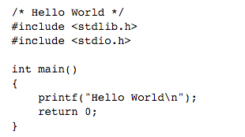

### Syntax Highlighting

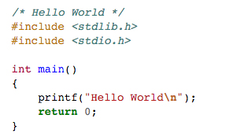

Themes are a way for you to customize how the syntax highlighting works in your text editor. There are literally thousands of themes out there for you to pick from or you can create your own.

# Installing Packages and Themes

Read the instructions below for how to install packages and themes in Sublime or Atom. If you’re using a different text editor, you’ll need to refer to their documentation.

## Sublime Text

In Sublime, packages can be installed using Package Control. Package Control is an open-source tool that manages packages in Sublime. You can download it by clicking [**this link**](https://packagecontrol.io/) and following the instructions.

After you’ve installed Package Control and restarted Sublime, you can access it by launching the Command Palette and typing Package Control. To open the Command Palette, press ⌘ + ⇧ + P (Mac) or Ctrl + ⇧ + P (Windows/Linux). Once there, you will be able to issue commands for installing, removing, and listing packages.



## Atom

To install packages and themes in Atom, simply navigate to Atom → Preferences and click on the “Install” tab. From there, you can toggle between searching for packages and themes.



After you’ve installed a package or theme, you can click on their associated tabs from Settings to manage them. If you'd like more help getting started, check out [**Atom's documentation**](https://atom.io/docs/latest/using-atom-atom-packages).

# Recommended Packages

Sublime and Atom have thousands of packages available to install, but figuring out which ones to use can be a task in itself. So, below we’ve recommended some packages that you will definitely want to install (these packages are available in both Sublime and Atom). **After you install a package, make sure to restart your text editor in order for the changes to take effect.**

## Emmet

Emmet is a plugin for text editors that enables web developers to write HTML and CSS code faster. It does this by expanding simple CSS-like abbreviations into complex HTML and CSS code snippets.



Emmet is a must-use for any web developer. To learn more about how Emmet works, check out [**this article**](https://www.smashingmagazine.com/2013/03/goodbye-zen-coding-hello-emmet/) written by Smashing Magazine or visit [**Emmet’s official website**](http://emmet.io/).

## Color Highlighter

Color Highlighter is a plugin for Sublime, which unobtrusively previews color values in your code. Also, Color Highlighter comes with a built-in color picker and color format converter (hex, rgb, etc.) to make changing colors a breeze.



To read more about Color Highlighter, check out their [**GitHub repo**](https://github.com/Monnoroch/ColorHighlighter) or visit their page on the [**Package Control website**](https://packagecontrol.io/packages/Color%20Highlighter).

## Pigments

Pigments is a plugin for Atom that displays color in code. Similar to Color Highlighter for Sublime, Pigments unobtrusively previews color values in your code. Also, Pigments will scan source files in your project directories looking for colors and will build a palette with all of them. That’s pretty sweet!



To find out more about Pigments, visit their [**official page**](https://atom.io/packages/pigments) on Atom’s website.

## Sublime Tutor

Sublime Tutor is an interactive, in-editor keyboard shortcuts tutorial for Sublime Text 3. Do you want more practice using keyboard shortuts? Are you insterested in learning even more shortcuts than what is covered in this lesson? If so, install Sublime Tutor and get started!

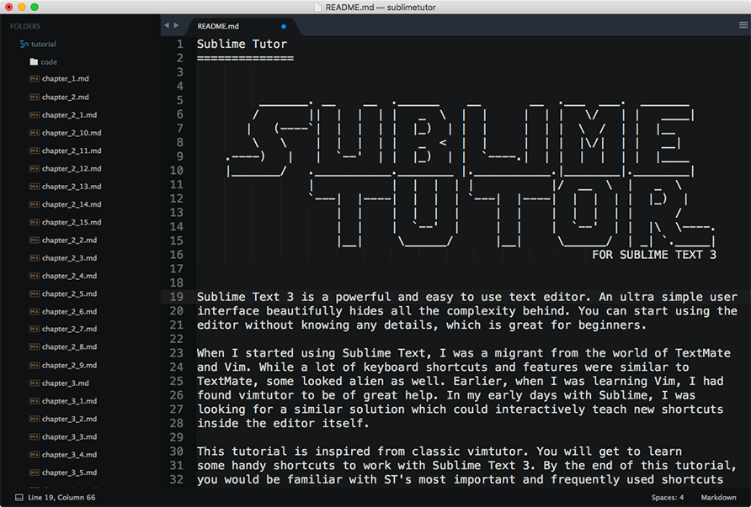

Sublime Text 3 is required for this package. If you haven't upgraded to Sublime Text 3, you can download [**here**](https://www.sublimetext.com/3).

### Want More Packages?

If you want to see the complete list of packages available in Sublime, head on over to [**https://packagecontrol.io/**](https://packagecontrol.io/).

If you are looking for packages in Atom, you can simply visit [**their website**](https://atom.io/) and search for them there.

# Recommended Themes

Want your syntax highlighting to stand out? Below we’ve selected some of our favorite themes that we use here at Udacity. No theme is right or wrong, it’s really up to personal preference.

## Monokai

Based on the original TextMate theme designed by **[Wimer Hazenberg](https://twitter.com/monokai" \t "_blank)**, Monokai has become widely popular over the years. Monokai is the default color scheme used by Sublime; however, it is widely available on most text editors and IDEs.

**[[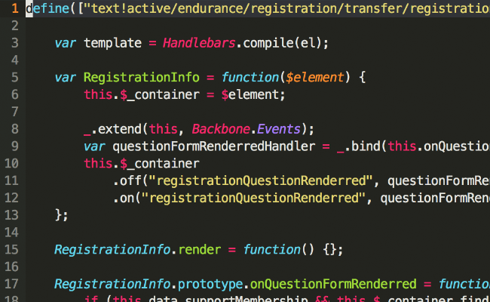](https://classroom.udacity.com/nanodegrees/nd001/parts/aabd87fc-6edf-4818-a911-15dfa9cabcb8/modules/4d4626ff-de39-4af7-9cf1-a26774ee022c/lessons/7118285430/concepts/73043185410923)](https://classroom.udacity.com/nanodegrees/nd001/parts/aabd87fc-6edf-4818-a911-15dfa9cabcb8/modules/4d4626ff-de39-4af7-9cf1-a26774ee022c/lessons/7118285430/concepts/73043185410923)**

## Solarized

Solarized is a sixteen color palette (eight monotones, eight accent colors) designed by [**Ethan Schoonover**](https://twitter.com/ethanschoonover) for use with terminal and GUI applications. The color scheme uses both precise lightness relationships and a refined set of hues based on fixed color wheel relationships.

**[[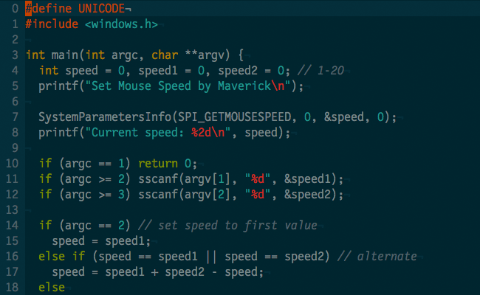](https://classroom.udacity.com/nanodegrees/nd001/parts/aabd87fc-6edf-4818-a911-15dfa9cabcb8/modules/4d4626ff-de39-4af7-9cf1-a26774ee022c/lessons/7118285430/concepts/73043185410923)](https://classroom.udacity.com/nanodegrees/nd001/parts/aabd87fc-6edf-4818-a911-15dfa9cabcb8/modules/4d4626ff-de39-4af7-9cf1-a26774ee022c/lessons/7118285430/concepts/73043185410923)**

## Udacity

Prefer to use the same theme as the Udacity faithful? Check out the Udacity theme in Atom!

**[[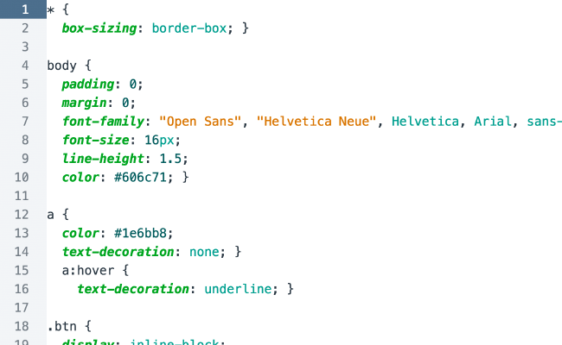](https://classroom.udacity.com/nanodegrees/nd001/parts/aabd87fc-6edf-4818-a911-15dfa9cabcb8/modules/4d4626ff-de39-4af7-9cf1-a26774ee022c/lessons/7118285430/concepts/73043185410923)](https://classroom.udacity.com/nanodegrees/nd001/parts/aabd87fc-6edf-4818-a911-15dfa9cabcb8/modules/4d4626ff-de39-4af7-9cf1-a26774ee022c/lessons/7118285430/concepts/73043185410923)**

### Want More Themes?

Check out [**https://packagecontrol.io/browse/labels/theme**](https://packagecontrol.io/browse/labels/theme) to find more themes to make your Sublime text awesome!

If you are looking for themes in Atom, you can simply visit [**their website**](https://atom.io/) and search for them there.

**What is a Lab?**

A Lab is an automatically graded assignment and is a graduation requirement.

In this Lab, you'll develop a trading card for an animal. On the following page, you'll be able to launch your Lab. Inside the Lab, you'll be given instructions and a workspace where you can code your project.

When you're ready to see how you're doing, press the "Run Code" button! A panel will open to display the progress of the automatic grader. If one of the rules doesn't pass, make sure to read the grader's feedback carefully to see what needs to be changed.

**What should you know to begin?**

To be successful in this Lab, you'll need to have skills in:

* HTML skills
  + adding a class to an element
  + modifying text content
* CSS skills
  + adding a border
  + adding padding
  + italicizing text
  + altering list item bullets